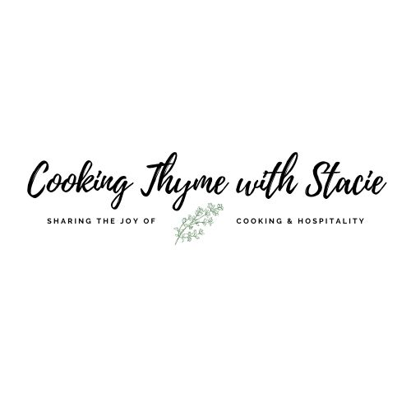

TJ’s for 2 Taco Night

Menu
Breaded Shrimp Tacos
Sweet and Spicy Cabbage Slaw with
Special Sauce
Black Bean and Roasted Corn Medley
Cranberry Mojito

To access the class video copy and paste the following link into your browser:

www.cookingthymewithstacie.com/video-class-purchase/tjtaco2

www.cookingthymewithstacie.com

Trader Joe’s Shopping List

** All ingredients for this class can be purchased at Trader Joe’s (except the rum and cranberry raspberry juice which is a seasonal product)!

Dairy/Freezer
- 1 bag gluten free breaded shrimp
- 1 bag fire roasted corn

Pantry
- Granulated sugar (if you need to make simple syrup for cocktail)
- ½ cup mayonnaise
- ¼ cup Trader Joe’s sweet chili sauce
- Coconut Oil (it is in a jar and looks solid)
- 1 package Trader Joe’s wheat and corn tortillas
- 1 can Trader Joe’s organic black beans, drained and rinsed
- 1 small can Trader Joe’s mild green chilis
- 2/3 cup Trader Joe’s chunky jarred salsa

Produce
- 1 bag Trader Joe’s red and green cabbage with carrots
- 2 limes
- 1 package fresh mint
- 1 package fresh cilantro
- ½ red onion

Spices
- Trader Joe’s Chile Lime seasoning

Specialty
- Light rum
- Cranberry Raspberry juice
- Tonic water

Equipment List

Pots and Pans
- Large non-stick skillet
- Large pot

Utensils
- Cutting board
- Chef’s knife
- Measuring cups and spoons
- Mixing bowls
- Spatula
- Tongs
- Wooden spoon

Specialty
- Cocktail shaker, if desired

Mis en Place
The French culinary term for “everything in its place”
In order to have a smooth cooking experience, I recommend that you retrieve all the equipment you will need for the class before we begin. In addition, if you have time, group your ingredients by recipe. Most chefs place their components on sheet pans – this is ideal if you have the room.

- Make the simple syrup for the cocktail – see attached recipe

Trader Joe’s Breaded Shrimp Tacos

Serving 2 (You can easily double the recipe and make enough for 4)

16 Trader Joe’s Frozen Gluten Free Breaded Shrimp (enough for 2 tacos per person)
2 TSP Trader Joe’s Coconut Oil
Trader Joe’s Chile Lime Seasoning
4 Trader Joe’s Wheat and Corn Tortillas

In a 12” non-stick skillet, melt the oil. Once melted and bubbling, add the FROZEN shrimp to the pan in a single layer. Cook 3 - 4 minutes on the first side, then flip. Cook an additional 3 minutes on the second side. Season lightly with a sprinkling of Trader Joe’s Chile Lime seasoning.

Serve in tortillas with cabbage slaw and special sauce.

I warm my tortillas directly on the gas stovetop. Alternatively, you may wrap them in foil and heat in a 325˚ oven for 8 minutes.

Cabbage Slaw with Special Sauce

1 bag Trader Joe’s red and green cabbage with carrots
2 Tb special sauce

Mix ½ bag of the slaw with the special sauce. Refrigerate until ready to use.

Special Sauce

½ cup mayonnaise
¼ cup Trader Joe’s sweet chili sauce
1 TSP Trader Joe’s Chile Lime seasoning
Juice from ½ lime

Whisk together all the ingredients. Set aside 2 TB for the slaw.

To serve: I place the remaining sauce in a Ziploc bag, cut the corner and drizzle over the tacos.

Roasted Corn and Black Bean Medley

1 TB Trader Joe’s Coconut Oil
½ cup red onion, chopped (about ½ a medium size onion)
2 cups Trader Joe’s frozen fire-roasted corn
1 can Trader Joe’s organic black beans, drained and rinsed
1 small can Trader Joe’s mild green chilis
2/3 cup Trader Joe’s chunky jarred salsa
2 TSP Trader Joe’s Chile Lime seasoning
3 Tb chopped fresh cilantro to garnish

In a large non-stick pan, melt the coconut oil over medium-low heat. Add the chopped onion, cook 5 minutes, stirring often. Add the 2 cups of frozen corn. Cook an additional 4 minutes, stirring frequently. Once the corn has thawed, add the can of green chilis, the rinsed and drained black beans, the salsa and seasoning. Stir to combine. Cook over low heat until thoroughly heated through. Garnish with fresh cilantro.

Cranberry Mojito

Makes 1 Serving

1 TB simple syrup
2 ounces light rum
3 ounces cranberry raspberry juice
8 mint leaves
2 ounces chilled tonic water
Squeeze of fresh lime

In a tall glass muddle the mint leaves and simple syrup. Add the rum and cranberry juice. Stir. Then add some ice and top with the tonic water and a squeeze of lime.

** To make simple syrup add ½ cup granulated sugar and ½ cup water to a small saucepan. Heat over low and stir frequently until the sugar has dissolved

Note: I use the cranberry raspberry juice since it is less tart than the straight cranberry juice!

