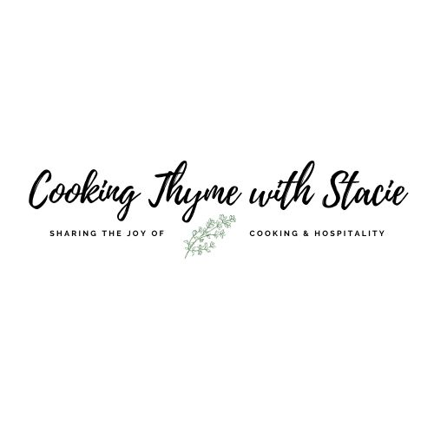

Asian Bistro

- Menu –
Sesame Noodle Salad
Sticky Asian Chicken
Thai Tea

To access the class video copy and paste the following link in to your browser:

www.cookingthymewithstacie.com/video-class-purchase/ab92021

www.cookingthymewithstacie.com

Shopping List

Pantry
- ¼ cup plus 2 TB soy sauce
- 5 TB sesame oil
- 7 TB olive oil
- 2 TB brown sugar
- 8 ounces linguine (1/2 box)
- 1 TB hoisin sauce (you will find this in the Asian aisle of your grocery store)
- 1 TB sweet chili sauce (you will find this in the Asian aisle of your grocery store)

Produce
- 1 red pepper
- 1 yellow pepper
- 1 cup sugar snap peas, strings removed
- 1 carrot, shredded (about 1 cup)
- ½ English cucumber, halved and sliced
- 2 cups shredded cabbage (shortcut – buy pre-shredded coleslaw mix)
- 1 cup cilantro
- 1 jalapeño, minced (optional)
- 4 green onions
- 1 lime
- 3 ½ TB freshly grated ginger
- 4 garlic cloves, minced

Protein
- 2 pounds boneless, skinless chicken thighs

Optional: If you wish to make the Thai tea

- Cha Tra Mue Thai Tea - from Amazon
- Can of condensed milk
Equipment
Pots and Pans
- Large pot for boiling noodles
- Large skillet

Utensils
- Chef’s knife
- Cutting Board
- Box grater
- Measuring cups and spoons
- Mixing bowls
- Thermometer
- Whisk

Specialty
- Fillable Tea bags or a French press to make the tea

Mis en Place
The French culinary term for “everything in its place”

In order to have a smooth cooking experience, I recommend that you retrieve all the equipment you will need for the class before we begin. In addition, if you have time, group your ingredients by recipe. Most chefs place their components on sheet pans – this is ideal if you have the room.

Measuring things in advance is optional, but I find if I measure things in advance I am less likely to get lost… such as “did I put in the baking powder?”

- Most of the time preparing this dinner is the chopping of ingredients for the noodle salad!
You may want to get a little ahead and chop a few things before we start.

Sesame Noodle Salad

For the salad
1 red pepper, thinly sliced
1 yellow pepper, thinly sliced
1 cup sugar snap peas
1 carrot, shredded (about 1 cup)
½ English cucumber, halved and sliced
2 cups shredded cabbage
1 cup cilantro
1 jalapeño, minced (optional)
8 ounces linguine
For garnish: 4 green onions, sliced, green parts only

For the dressing
3 TB grated ginger
3 TSP garlic, minced
¼ cup soy sauce
2 TB sesame oil
4 TB olive oil
1 TB brown sugar
Zest and juice of 1 lime

Bring a large pot of salted water to boil. Add the linguine and cook until al dente, about 10 minutes. Drain and rinse with cold water. Set aside.

Prepare all the vegetables: peppers, peas, carrots, cucumbers and cabbage, place them in a very large bowl. Next chop up the cilantro and add it to the bowl. You may add the jalapeño for a little extra heat.

Add the linguine to the bowl and toss with the vegetables.

In a medium bowl, whisk together the dressing ingredients. Pour the dressing over the linguine mixture and toss until well coated. Garnish with sliced green onions.
Chill covered until ready to serve.

Sticky Asian Chicken

2 pounds boneless, skinless chicken thighs
3 TB olive oil
2 TB soy sauce
1 TB hoisin sauce
1 TB brown sugar (optional – you can leave out)
1 clove fresh garlic, minced
½ TSP fresh ginger, grated
1 TB sweet chili sauce

Bring the chicken to room temperature.

In a small bowl, whisk together: soy, hoisin, sugar, garlic, ginger, sweet chili sauce and set aside.

In a large skillet add the olive oil and heat over to medium.

Add the chicken in a single layer. Sauté three minutes on the first side then flip and cook another three minutes. Flip the chicken over and pour the sauce over the chicken. Continue to cook the chicken until a thermometer reads 165˚ F in the thickest part. Using a large spoon, baste the chicken with the sauce as it cooks.

Thai Tea

Making Thai tea like the restaurant is all in the type of tea!
I recommend purchasing
Cha Tra Mue Brand from Amazon

Tea Mix:
The package suggests 2 grams of tea for 1 cup of boiling water. I found this to be too weak once I added the ice and milk. I think 4 grams of tea mix to 1 cup of water is better tasting.

Brewing:
Using a French press or tea bags will prevent the fine pieces of mix to get into your brewed tea. Otherwise brew the tea in a large pot and then strain it through some cheese cloth.

Sweetness:
You can select how sweet you prefer. I use a simple syrup of equal parts water and sugar to slightly sweeten the tea followed by 2 TB condensed milk for an 8 ounce glass of Thai tea.

